English Online Interview (EOI)

Guide

Contents

1. Introduction 4

What is the English Online Interview? 4

Assessment Modules 4

Mandatory assessment of Foundation and Grade 1 Students 5

Insight Assessment Platform 5

Supporting Resources and Professional Learning 5

Roles and Responsibilities within the School 5

Communicating about the EOI and Students’ results with Parents and Carers 6

2. Preparing for the assessment 7

Checking the class set up and Student details 7

Becoming familiar with the EOI 7

Which students can be assessed? 7

EOI exemptions 8

Students enrolled in more than one school 9

EOI kits 9

Resources required for each Module 10

3. The EOI modules in more detail 11

Module 1 Overview 12

Module 2 Overview 13

Module 3 Overview 15

Module 4 Overview 16

4. Administering the EOI 18

Assessment view 18

5. Recording student responses 20

Using the scoring rubrics to evaluate student responses 20

Phonics rubrics 21

Writing rubrics 22

6. Student Profile 24

How to Access 24

About the Student Profile 24

Features of the Student Profile 24

EOI Data 25

Areas of Literacy 25

7. Reports 26

Indicative Victorian Achievement Level 26

8. Summary of Reports 27

EOI Summary 27

Class Profile 28

EOI to DATE Report - Class 29

EOI to DATE Report – Students 30

Item Analysis Report 31

EOI Module Comparison Report 33

Class Diagnostic 34

Grouping Report by EOI mode or task 35

Custom Reports 36

Student History 37

Assignment Reviews – Individual students 38

9. Help and Support 39

EOI Technical Support 39

Further Support 39

# Introduction

 Use this icon to identify key information in this guide.

## What is the English Online Interview?

The English Online Interview (EOI) is an online tool for assessing the English skills of students from Foundation to Level 2 that includes 4 modules and is aligned to English in the Victorian Curriculum F-10. The EOI is a one-to-one interview between a teacher and student, using specifically designed texts and downloadable resources to complete a module. Teachers record each student's responses directly onto the online system (the Insight Assessment Platform). This data is used to generate a range of reports that provide an overview of student achievement and information to inform program planning and resource allocation.

 **The EOI assesses achievement in the 3 modes of English in the Victorian Curriculum F-10:**

* **Reading and Viewing**
* **Writing**
* **Speaking and Listening.**

**The assessment covers the following areas of literacy:**

* **concepts about print**
* **listening comprehension**
* **oral language (conversation)**
* **oral language (vocabulary)**
* **phonics and phonological awareness**
* **reading comprehension**
* **writing and spelling.**

The most up-to-date information about the EOI can be found on the dedicated [EOI web page.](https://www.schools.vic.gov.au/english-online-interview)

## 

## Assessment Modules

The EOI is organised into 4 separate modules. Each module:

* assesses a student in Reading and Viewing, Writing, and Speaking and Listening
* is designed around expected achievement at particular stages of schooling
* recognises the broad range of skills and abilities within a year level and is designed to cater for this range.

Although there are some similarities between each module, each uses different reading texts, as provided in the EOI kit, and asks different questions. The EOI kit contains a reading text and picture storybook text for each of the 4 modules (8 texts in total) and is provided to all Victorian government schools. See the EOI kit section below for more information about kit contents and how to order kits.

**Teacher judgement should be used to inform the use of EOI modules with individual students, with guidance as follows:**

* **Module 1 is recommended for the start of Foundation**
* **Module 2 is recommended for the start of Grade 1**
* **Module 3 is recommended for the end of Grade 1**
* **Module 4 is suitable to assess students with results that indicate they are operating at a higher level than expected. Module 4 provides evidence of achievement at Victorian Curriculum Levels 2-4.**

All EOI modules may be used with individual students as appropriate for their literacy learning and development.

The Insight Assessment Platform can help track if a student has already completed a specific module and this should be reviewed prior to commencing an assessment with a student to avoid repeat use of the same module during the school year.

## Mandatory assessment of Foundation and Grade 1 Students

It is mandatory for all Foundation and Grade 1 students in Victorian government schools to be assessed during the Term 1 EOI assessment period. Schools are advised of the assessment period dates in Term 4 each year via a School Update and the dedicated [EOI webpage](https://www.schools.vic.gov.au/english-online-interview).

Please note:

* Module 1 can only be accessed during the mandatory Foundation assessment period at the start of each year. Students cannot be assessed using Module 1 outside this period.
* Module 2 closes when the mandatory assessment period for Grade 1 ends and then become available again for Terms 2-4 for formative assessment with individuals as needed.
* Modules 3 and 4 are open for the entire school year.

## Insight Assessment Platform

The EOI is hosted on the Victorian Curriculum Assessment Authority's Insight Assessment Platform which hosts other assessment tools such as the Diagnostic Assessment Tools in English (DATE) and Abilities Based Learning and Education Support (ABLES).

* Teachers record each student’s EOI responses directly into the online assessments located on the Insight Assessment Platform here: [www.vcaa.vic.edu.au/assessment/f-10assessment/insight/Pages/login.aspx](http://www.vcaa.vic.edu.au/assessment/f-10assessment/insight/Pages/login.aspx).
* Teachers can also view Modules 2-4 of the assessment via the [Insight Assessment Platform practice space](https://www.vcaa.vic.edu.au/assessment/f-10assessment/insight/Pages/practicespace.aspx).
* Task resources for the assessment items for each of the modules are located in the Insight Assessment Platform [learning library](https://det.linkitau.com/LearningLibrarySearch).

## 

## Supporting Resources and Professional Learning

* Insight Assessment Platform resources and support (VCAA page): [Insight Assessment Platform support resources](https://www.vcaa.vic.edu.au/assessment/f-10assessment/insight/Pages/govt-schools.aspx)
* Insight Assessment Platform practice site: [Pages - Practice Space (vcaa.vic.edu.au)](https://www.vcaa.vic.edu.au/assessment/f-10assessment/insight/Pages/practicespace.aspx)
* Dedicated EOI webpage with up-to-date information: [English Online Interview | Schools Vic](https://www.schools.vic.gov.au/english-online-interview)
* Virtual and on-demand EOI professional learning modules on the EOI [Arc | Events | Providers (educationapps.vic.gov.au)](https://arc.educationapps.vic.gov.au/eventhub/providers/AssessmentImpl) (please note these offerings do not remain constant throughout the year – visit the dedicated EOI web page for up-to-date information)
* The Insight Assessment Platform Reporting made available by the VCAA in 2023: [Insight Assessment Platform Reporting Guide](https://www.vcaa.vic.edu.au/Documents/insightplatform/ReportingGuide.docx)

## Roles and Responsibilities within the School

### Principal

The principal is responsible for:

* promoting the value of the EOI to staff
* ensuring that all Foundation and Grade 1 students are assessed in the mandatory assessment period
* ensuring all aspects of the organisation and conduct of the EOI are appropriately resourced
* nominating a staff member as an EOI school assessment administrator to oversee the mandatory assessment period
* providing adequate support and access to professional learning on the use of the EOI
* requesting extensions for students and/or classes, if needed
* ensuring assessments have been finalised and submitted for all Foundation and Grade 1 students by the end of the mandatory assessment period.

### EOI school assessment administrator

The EOI school assessment administrator nominated by the principal needs to:

* ensure that all teachers conducting the EOI are:
* familiar with the Insight Assessment Platform
* know how to conduct an EOI assessment (including remembering to click ‘submit’ when an assessment is complete)
* provide support and professional learning to other teachers, where required.

### Classroom teacher

**The EOI should be administered by the classroom teacher (rather than a casual relief teacher (CRT) or Education Support Staff) in order to produce the most accurate results. Teachers should:**

* **familiarise themselves with the EOI and how to conduct an assessment on the Insight Assessment Platform**
* **ensure they have the required texts and resources, including the EOI kit**
* **make judgements about the suitability of the EOI for individual students by referring to the exemption policy below**
* **access the EOI reports on the Insight Assessment Platform to inform their curriculum planning for individuals and groups of students.**

## Communicating about the EOI and Students’ results with Parents and Carers

Schools should communicate to parents and carers that the EOI is used in Term 1 each year with all Foundation and Grade 1 students in government primary schools to assess their literacy skills, including phonics.

At the time of administering the EOI at the beginning of the year, general information can be shared with parents and carers such as:

* ways to support their child with learning to read
* considering the distribution of the [Literacy and Numeracy Tips to Help your Child Every day](https://www.education.vic.gov.au/school/teachers/teachingresources/discipline/english/Pages/litparents.aspx) booklet to parents and carers as this resource provides practical tips for building children’s literacy and numeracy skills outside of the school environment. It suggests fun, inexpensive, accessible and practical activities that can be done at home or in the local community. Government school Foundation students receive a hard copy of this booklet in the Prep Bags.

It is not recommended that the EOI scores are shared with parents and carers as the scores are designed to inform teaching as one of the pieces of evidence gathered about a student’s learning. Instead, schools may consider providing the following information in a verbal or written report:

* providing a simple assessment report to parents and carers identifying what the assessment revealed in terms of what a student can do
* what their child’s teacher will focus on to support literacy learning
* tips on how the parents and carers can support their child at home as partners in their child’s learning.

If the EOI reveals concerns about a student’s literacy learning, the teacher should follow up with the individual’s parent or carer and develop an [Individual Education Plan](https://www2.education.vic.gov.au/pal/individual-education-plans-ieps/policy) as appropriate. For students who already have an Individual Education Plan, it is important that communication about the EOI results occurs with parents and carers in the context of the ongoing discussions about the individual’s learning needs.

# Preparing for the assessment

Conduct the EOI in a quiet comfortable space and ensure (as much as possible) that there are no interruptions. It is recommended that each individual assessment is conducted in one sitting for most students to ensure the most accurate and reliable results. Please refer to the guidance below in relation to students who are English as an additional language and/or diverse learners about options for conducting the interview in more than one sitting.

## Checking the class set up and Student details

**In the Insight Assessment Platform, classes and students are assigned to classroom teachers according to CASES21 data. For this reason, it is essential that the data held in CASES21 is accurate prior to the assigning of any assessments.**

Teachers will be able to assign assessments to the students in the classes assigned to them (including CASES21 home groups). EOI school assessment administrators and principals can also set up additional class groups and assign one or more teachers to these groups after CASES21 has been updated for the start of the school year.

See the [Insight Assessment Platform support resources](https://www.vcaa.vic.edu.au/assessment/f-10assessment/insight/Pages/govt-schools.aspx) for more information about student details and assigned classes.

## Becoming familiar with the EOI

All teachers should make sure they are familiar with the EOI kits, downloadable resources, assessment tasks and EOI reports before the formal assessment period commences. Modules 2-4 of the EOI can be viewed in the [Insight Assessment Platform practice space](https://www.vcaa.vic.edu.au/assessment/f-10assessment/insight/Pages/practicespace.aspx).

## Which students can be assessed?

The EOI is designed to assess students from Foundation to Level 2.

**All Foundation and Grade 1 students should be assessed during the mandatory assessment period, noting the EOI Exemptions advice below may apply to individual students.**

The one-to-one nature of the EOI allows teachers to gain additional information about students' learning strengths and challenges. It can be used with students who are learning English as an additional language (EAL learners) and diverse learners. Teachers should apply their judgement about whether it is appropriate for an individual student to be assessed or if they should be exempt (see EOI Exemptions below).

### EAL Learners

All reports generated from the EOI relate to the English learning area of the Victorian Curriculum F-10, and the data is not aligned to the [Victorian Curriculum](https://victoriancurriculum.vcaa.vic.edu.au/english/english-as-an-additional-language-eal/introduction/rationale-and-aims) F-10 EAL. If the EOI is completed with an EAL learner, teachers will need to interpret the results data and reports in relation to the expectations outlined in the Victorian Curriculum F-10 EAL. Teachers should consider this in determining whether the EOI provides the level of support needed to assess EAL learners appropriately.

It should be noted that the EOI assesses English skills and does not collect data on students’ proficiency in their home language. Teachers may choose to conduct the Victorian Curriculum Assessment Authority’s [Language and learning interview](https://www.vcaa.vic.edu.au/curriculum/foundation-10/resources/english-as-an-additional-language/planningresources/Pages/LanguageandLearningInterview.aspx) to gather information about a student’s prior learning experiences, including their development of literacy in their home language or other languages.

The Language and Learning interview can also provide information about any previous learning of English, so it may be useful in helping teachers decide whether to use the EOI with an individual student. If the student has little or no previous experience with English, is it unlikely that they will be able to participate in the EOI. If the EOI is not appropriate for an EAL learner, teachers may exempt the student (see EOI Exemptions below).

Teachers should monitor and be responsive to students’ reactions during the assessment. If the EOI is commenced with an EAL learner and it is clear the individual is uncomfortable and/or does not understand what is expected, the interview should cease, and the student be entered in the Insight Assessment Platform as exempt.

Students who are still learning the language can also become fatigued when using English for extended periods. In these cases, if the student would benefit from having their English abilities assessed, the EOI may take place in more than one sitting. It is recommended this occurs over the same day to ensure the most accurate and reliable results.

### Diverse Learners

Teachers should consider how individuals with diverse learning needs can be supported to demonstrate their English abilities by participating in the EOI. This may include:

* discussing the EOI process with the student’s parent or carer beforehand, to determine what adjustments may be needed to support the student to participate in the interview (e.g. breaks or use of sensory materials, such as sitting in a bean bag or using a fidget toy)
* reviewing the student’s Transition Learning and Development Statement and past Individual Education Plans may also be helpful to determine adjustments that may be needed
* explaining what is involved beforehand so the student understands what to expect e.g. creating a social story for students with autism who have been identified as benefitting from this strategy
* considering what time of day or day of the week might best suit an individual and what environment supports them to focus on a literacy task
* conducting the EOI in more than one sitting. It is recommended this occurs over the same day to ensure the most accurate and reliable results.

If the EOI is commenced with a diverse learner and it is clear the individual is uncomfortable and/or not understanding what is expected the interview should cease and the student be entered in the Insight Assessment Platform as exempt (see EOI Exemptions below).

## EOI exemptions

**The EOI has been developed for use with typically developing students and may not be suitable for students who are learning English as an additional language and students with disabilities. Teacher judgement and professional knowledge of the student will determine if the student can complete the assessment.**

If a student is unwell and/or absent from school during the Term 1 assessment period, a student may also be exempt.

The conditions for exemption are:

* a student who has a disability and/or a diverse learner such that they cannot perform in an assessment situation
* an EAL learner who has limited or no ability to respond or participate in the assessment due to limited English
* a student who is capable of being assessed but has a temporary disorder or illness and cannot complete the assessment
* a student who is capable of being assessed but is absent during the assessment period.

If undertaking the EOI is not appropriate for students with disabilities, the literacy components of the [Abilities Based Learning and Education Support](https://www.education.vic.gov.au/school/teachers/learningneeds/Pages/ables.aspx) (ABLES) may be more suitable. For more information see the ABLES webpage.

**If a teacher deems that an exemption is appropriate for a student, they must record this in the Insight Assessment Platform.**

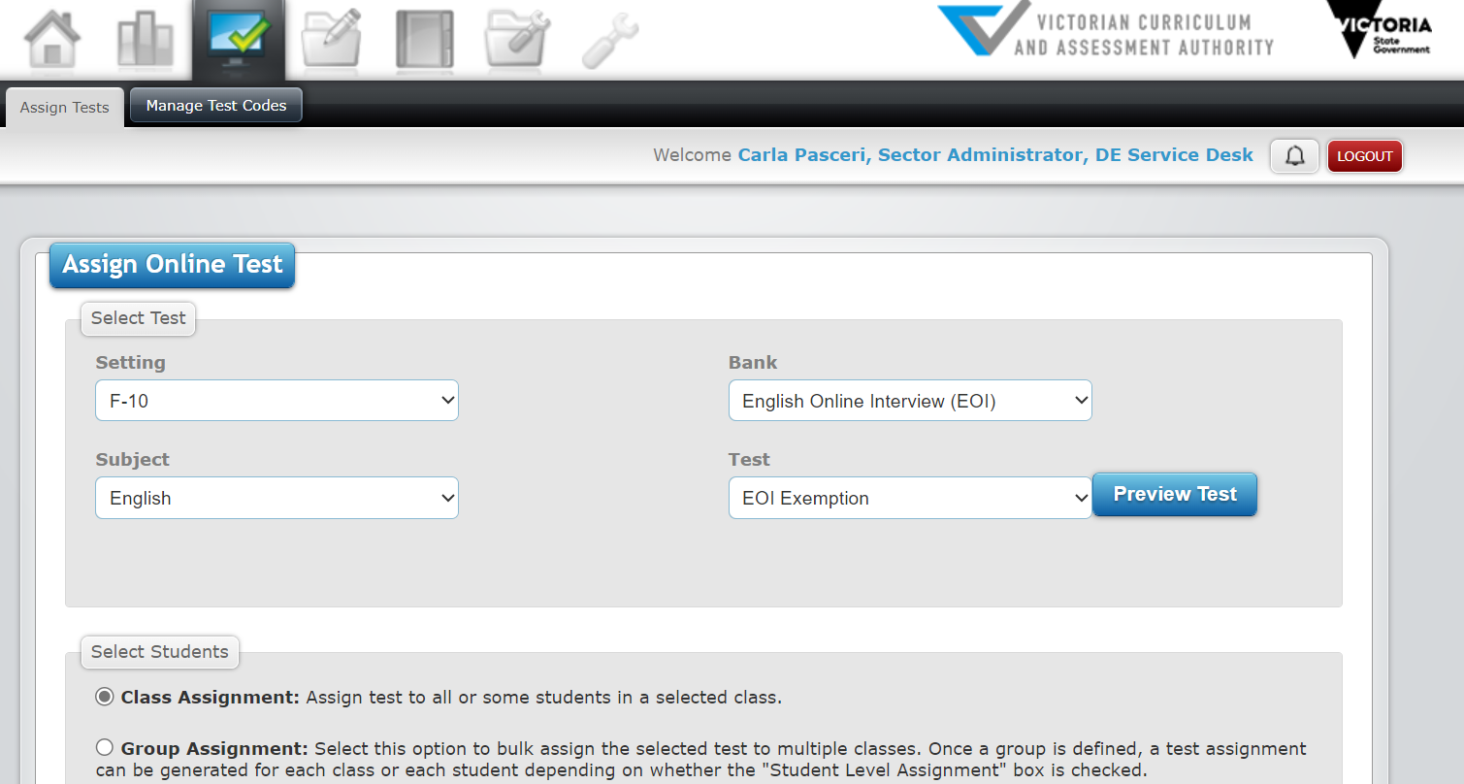

## Students enrolled in more than one school

Using the Insight Assessment Platform, assessment of the EOI can be conducted with all students enrolled in that school. Where a student is enrolled at 2 schools (e.g. if a student spends part of the week at a specialist school and part of the week at a mainstream school) they should only be assessed in one of those settings. It is recommended that the 2 schools coordinate to ensure the student is not assessed twice.

The Insight Assessment Platform can help track if a student has been assessed already and this should be reviewed prior to commencing an assessment with a student. Both schools will be able to view the data if the student appears in CASES21 in both schools.

## EOI kits

**All Victorian government primary schools receive EOI kits from the department free of charge, which contain the texts and information about the resources for each of the 4 modules. It is recommended that schools allocate one EOI kit per class. The texts should not be used for any purpose other than the EOI assessment and should be stored securely.**

Additional copies of the resources can also be downloaded and printed. These can be accessed via the links in this Guide below, within each of the EOI modules, and from the *Learning Library* tab in the Insight Assessment Platform.

Schools requiring new or replacement EOI kits should contact [studentlearning@education.vic.gov.au](mailto:studentlearning@education.vic.gov.au).

### EOI braille texts

Braille texts have been developed to support teachers to administer the EOI to blind students. A list of the texts available in Braille is provided on the [EOI braille text webpage](https://www.schools.vic.gov.au/english-online-interview-eoi-braille-texts).

Braille texts can be requested through the Statewide Vision Resource Centre (SVRC). Please note that Braille texts should be returned to the SVRC at the end of the assessment period.

Statewide Vision Resource Centre  
Phone: (03) 9841 0242  
Email: [svrc@svrc.vic.edu.au](mailto:svrc@svrc.vic.edu.au)

## Resources required for each Module

### Module 1

**Relevant EOI kit texts and resources**

Reading Text: Cupcakes

Picture Storybook Text: Clever Max

[Initial Sound Sheet](http://fuse.education.vic.gov.au/Resource/ByPin?Pin=YGB47Z&SearchScope=All) (one copy per class)

[Alphabet Sheet](http://fuse.education.vic.gov.au/Resource/ByPin?Pin=PKM7HN&SearchScope=All) - teacher (one copy per class)

[Alphabet Recording Sheet](http://fuse.education.vic.gov.au/Resource/ByPin?Pin=L92N85&SearchScope=All) - student (one copy per student)

[The Family Picnic Storytelling Illustration](https://fuse.education.vic.gov.au/Resource/ByPin?Pin=2HXDKQ&SearchScope=All) (one copy per class)

[Phonics Word list](https://fuse.education.vic.gov.au/?8NFG29) (one copy per class)

[Annotated Writing Samples for Writing Task Assessment](http://fuse.education.vic.gov.au/Resource/ByPin?Pin=J8RQ7Z&SearchScope=All) (one copy per class)

### Module 2

**Relevant EOI kit texts and resources**

Reading Text: The Beach Ball

Picture Storybook Text: The Lunch Boxes

[Alphabet Sheet](https://fuse.education.vic.gov.au/?J9S2BJ) – teacher (one copy per class)

[Alphabet Recording Sheet - student](https://fuse.education.vic.gov.au/?74KWDX) (one copy per student)

[‘ick’ word sheet](https://fuse.education.vic.gov.au/?CK5D9T) (one copy per class)

[Phonics Word list](https://fuse.education.vic.gov.au/?LR4S2C) (one copy per class)

[A Day at the Beach Storytelling Illustration](https://fuse.education.vic.gov.au/Resource/ByPin?Pin=X7BL45&SearchScope=All) (one copy per class)

[The Beach Ball Running Record Sheet](http://fuse.education.vic.gov.au/Resource/ByPin?Pin=4MJD5H&SearchScope=All) (one copy per student)

[Annotated Writing Samples for Writing Task Assessment](https://fuse.education.vic.gov.au/?SD84WP) (one copy per class)

### Module 3

**Relevant EOI kit texts and resources**

Reading Text: Blackie’s Holiday

Picture Storybook Text: Tap Dancing Star

[Backyard Antics Storytelling Illustration](https://fuse.education.vic.gov.au/Resource/ByPin?Pin=ZTMHQ4&SearchScope=All) (one copy per class)

[P Word Sheet](https://fuse.education.vic.gov.au/Resource/LandingPage?ObjectId=85580f24-0112-4922-91cc-0a293b279094) (one copy per class)

[Phonics Word list](https://fuse.education.vic.gov.au/?2HMZPR) (one copy per class)

[Spelling Words - Teacher](http://fuse.education.vic.gov.au/Resource/ByPin?Pin=Z8JMLR&SearchScope=All) (one copy per class)

[Spelling Sheet – Student](http://fuse.education.vic.gov.au/Resource/ByPin?Pin=KCP8TN&SearchScope=All) (one copy per student)

[Blackie’s Holiday Running Record Sheet](https://fuse.education.vic.gov.au/?WN84FD) (one copy per student)

[Annotated Writing Samples for Writing Task Assessment](https://fuse.education.vic.gov.au/?Y9MM28) (one copy per class)

### Module 4

**Relevant EOI kit texts and resources**

Reading Text: Tiger and the Big Wind

Picture Storybook Text: The Golden Carambola Tree

[The Jungle Play Storytelling Illustration](https://fuse.education.vic.gov.au/Resource/ByPin?Pin=SBSWJ7&SearchScope=All) (one copy per class)

[Phonics Word list](https://fuse.education.vic.gov.au/?8J54WD) (one copy per class)

[Spelling Words - Teacher](http://fuse.education.vic.gov.au/Resource/ByPin?Pin=D7FWTZ&SearchScope=All) (one copy per class)

[Spelling Sheet - Student](http://fuse.education.vic.gov.au/Resource/ByPin?Pin=M4WBYB&SearchScope=All) (one copy per student)

[Tiger and the Big Wind Running Record Sheet](https://fuse.education.vic.gov.au/Resource/LandingPage?ObjectId=e3b18457-2013-4c83-b9d5-72f28beda85b) (one copy per student)

[Annotated Writing Samples for Writing Task Assessment](https://fuse.education.vic.gov.au/?K9BMJL) (one copy per class)

# The EOI modules in more detail

Each of the 4 assessment modules contains a series of tasks. Although all tasks can be conducted in a one-to-one situation, teachers may prefer to conduct some tasks, such as writing and spelling, with a small group of students or the whole class. The tasks for each module are outlined below.

**Module 1**

* Oral Language (Conversation Task)
* Phonological Awareness (including phonemic awareness)
* Reading: Cup Cakes
* Storytelling and Vocabulary Task: The Family Picnic
* Words and Sounds
* Phonics (real words and non-words)
* Comprehension: Clever Max
* Writing Activity: Clever Max

**Module 2**

* Oral Language (Conversation Task)
* Phonological Awareness (including phonemic awareness)
* Reading: The Beach Ball
* Storytelling and Vocabulary Task: A Day at the Beach
* Words and Sounds
* ‘Ick’ Words
* Phonics (real words and non-words)
* Comprehension: The Lunch Boxes
* Writing Activity: The Lunch Boxes

**Module 3**

* Oral Language (Conversation Task)
* Phonological Awareness (including phonemic awareness)
* Reading: Blackie’s holiday
* Storytelling and Vocabulary Task: Backyard Antics
* Segmenting words: p words
* Phonics (real words and non-words)
* Comprehension: Tap Dancing Star
* Writing Activity: Tap Dancing Star
* Spelling

**Module 4**

* Oral Language (Conversation Task)
* Reading: Tiger and the Big Wind
* Phonics (real words and non-words)
* Comprehension: The Golden Carambola Tree
* Storytelling and Vocabulary Task: The Jungle Play
* Writing Activity: The Golden Carambola Tree
* Spelling

## Module 1 Overview

### Oral language and listening comprehension

Oral language is foundational for literacy learning. As students engage in purposeful conversations, they express meaning and interpret messages conveyed by others.

The conversation task is intended as an icebreaker to help the student feel comfortable in the one-to-one interview situation, as well as providing a context for answering all subsequent questions. In Module 1, questions that assess oral language and listening comprehension are covered by the conversation, vocabulary, and storytelling tasks, as well as the retell questions.

#### Conversation Task

* Contribution to a conversation
* Quality of ideas and vocabulary
* Clarity of speech

#### Vocabulary and Storytelling Task

* Nouns
* Verbs
* Synonyms
* Narrative skill
* Quality of ideas
* Grammar
* Linking

#### Retelling Task

* Including the context, complication, resolution, and story end in the retell
* Number of logically sequenced events included in the retell
* Vocabulary and sentence structure used

### Phonological awareness

Students learn about the sounds and patterns of language, develop knowledge of individual sounds in spoken words, and make links between sounds and letters. In Module 1, questions assess students’ skills in manipulating spoken words and sounds.

#### Phonological Awareness

* Identifying and generating rhyming words and sounds

#### Phonemic Awareness

* Initial sound identification in a word
* Final sound identification in a word

#### Phonics

* Upper- and lower-case alphabet names and sounds
* Decode real English words and non-words

### Reading: accuracy, comprehension and concepts of print

Students learn how to look at print and recognise that print tells a story. As students learn to do this, they can identify, interpret, and explain key events.

#### Reading, Vocabulary and Storytelling Tasks

* Concepts of print – student’s ability to identify common print conventions
* Identify how the story ends based on illustrations
* Locate words as they are read by teacher
* Read/attempt to read words or tell a story based on the pictures
* Recognise and read/attempt to read an above-expected level text type

#### Comprehension Tasks

* Predict story from cover
* Identify prominent directly stated information
* State the reason for a character’s feelings
* Explain key events
* Identify a main idea
* Make a complex inference
* Link information across the text to explain a character’s actions.

### Writing

Students learn how to use their knowledge of oral language to compose messages. They record their messages using what they know about how print works. In Module 1, students are asked to write their name, draw a picture about the main character in the story they have just heard, write about their picture, and tell the teacher what their ‘writing’ says.

#### Writing Task

* Write their name
* Write about their picture
* ‘Read’ (make meaning from) their own writing attempt
* Write ‘readable’ or recognisable words
* Write relevant content.

## Module 2 Overview

### Oral language and listening comprehension

Students use oral language to communicate successfully with others. As they listen to and respond to the ideas of others, they learn to flexibly use appropriate vocabulary. The conversation task is intended as an icebreaker to help the student feel comfortable in the one-to-one interview, as well as providing a context for answering all subsequent questions. In Module 2, questions that assess oral language and listening comprehension are covered by the conversation, and vocabulary and storytelling tasks, and the retell questions.

#### Conversation Task

* Contribution to a conversation
* Quality of ideas and vocabulary
* Clarity of speech

#### Vocabulary and Storytelling Task

* Verbs
* Adjectives
* Synonyms
* Narrative skill
* Quality of ideas
* Grammar
* Linking

#### Retelling Task

* Including the context, complication, resolution and story end in the retell
* Number of logically sequenced events included in the retell

### Phonological awareness

Students become aware of the sounds in language. As students learn how to manipulate the sounds in spoken words, by substituting initial and final sounds in words, they are learning how to recognise patterns within print. In Module 2, phonological awareness, phonemic awareness and phonics questions assess students’ skills in manipulating spoken words.

#### Phonological Awareness

* Identifying and generating rhyming words and sounds

#### Phonemic Awareness

* Segment one syllable words into individual sounds
* Sound manipulation in one syllable words
* Sound manipulation of same-syllable constructs

#### Phonics

* Upper- and lower-case alphabet names and sounds
* Decode real English words and non-words

### Reading: accuracy, comprehension and concepts of print

Reading books requires the integration of several sources of information to establish meaning. Students use the illustrations to predict the author’s message, read some words accurately and use some punctuation conventions. In Module 2, reading comprehension, reading accuracy and concepts of print questions assess reading skills.

#### Reading, Vocabulary and Storytelling Tasks

* Concepts of print – student’s ability to identify common print conventions
* Read title
* Read in meaningful phrases, with expression and effective use of pausing, punctuation, and pacing
* Self-correct
* Recognise and read/ attempt to read above-level text type
* Predict story through title and/or cover illustrations
* Identify prominent, directly stated information
* Link illustrations and text to explain events.

#### Comprehension Task

* Link information across the text to explain a character’s actions
* Recall prominent, directly stated information
* Make a complex inference
* Link illustrations and text to explain events.
* Recognise a common graphic convention to show ‘thinking’

### Writing

Students learn how to write for a variety of purposes. They write simple sentences about personally relevant ideas and events, using some high frequency words and appropriate punctuation.

#### Writing Task

* Write their name
* ‘Read’ (make meaning from) their own writing attempt
* Write ‘readable’ or recognisable words
* Write relevant content
* Create simple sentences with conjunctions
* Spell high frequency words and 2-syllable words
* Include full stops and/or capital letters

## Module 3 Overview

### Oral language and listening comprehension

Students communicate effectively with others. As they communicate in a range of contexts, they listen to others and respond appropriately. The conversation task is intended as an icebreaker to help the student feel comfortable in the one-to-one interview situation, as well as providing a context for answering all subsequent questions. In Module 3, questions that assess oral language and listening comprehension are covered by the conversation, and vocabulary and storytelling tasks, and the retell questions.

#### Conversation Task

* Contribution to a conversation
* Quality of ideas and vocabulary
* Clarity of speech

#### Vocabulary and Storytelling Tasks

* Adverbs
* Synonyms
* Narrative skill
* Quality of ideas
* Grammar
* Linking

#### Retelling Task

* Including the context, complication, resolution, and story end in the retell
* Number of logically sequenced events included in the retell

### Phonological awareness

Students become more competent at hearing and orally manipulating the sounds in words. This contributes to the development of independent problem-solving of words in reading and writing.

#### Phonemic Awareness

* Manipulate first, last and middle sounds in one-syllable words
* Segmentation of 2 and 3 syllable words

#### Phonics

* Decode real English words and non-words

### Reading: accuracy, comprehension and concepts of print

Students read more complex texts using a variety of problem-solving strategies to accurately read and comprehend. Students interpret the author’s message, read in meaningful phrases, and use a variety of word-solving strategies. In Module 3, the reading comprehension and reading accuracy questions assess students’ reading skills.

#### Reading, Vocabulary and Storytelling Tasks

* Concepts of print – student’s ability to identify common print conventions
* Read in meaningful phrases, with expression and effective use of pausing, punctuation, and pacing
* Self-correct
* Identify prominent directly stated information
* Link illustrations and text to explain events
* Link information across the text to explain a character’s actions
* Use evidence from the text to support opinion

#### Comprehension Task

* Recognise a common graphic convention
* Link illustrations and text to explain events
* Interpret a metaphor
* Identify a cause and its effect
* Recall prominent directly stated information
* Use evidence from the text to support an opinion

### Writing and spelling

Students write for a variety of purposes. They develop their ideas in a clearly defined sequence. They use some high frequency words and regular spelling patterns.

#### Writing Task

* Construct a story with a beginning, some development of ideas and an ending
* Select appropriate and varied vocabulary
* Spell high frequency words and less regular 2-syllable patterns
* Include full stops and capital letters

#### Spelling Task

* 2 x one syllable simple
* 2 x one syllable consonant blends
* 1 x one syllable irregular pattern
* 1 x two syllable simple
* 1 x two syllable irregular
* 1 x three syllable simple
* 2 x two syllable irregular pattern

## Module 4 Overview

### Oral language and listening comprehension

Students engage in purposeful conversation. They put simple ideas into logical sequence or order, using appropriate volume, pace, and tone, relevant vocabulary, and responsive listening strategies. The conversation task is intended as an icebreaker to help the student feel comfortable in the one-to-one interview situation, as well as providing a context for answering all subsequent questions. In Module 4, questions that assess oral language and listening comprehension are covered by the conversation and vocabulary and storytelling tasks, and the retell questions.

#### Conversation Task

* Participation/engagement
* Spoken text structure
* Use of volume, tone, pace, expression and non-verbal cues
* Vocabulary
* Strategies

#### Vocabulary and Storytelling Tasks

* Verbs and adverbs
* Synonyms
* Narrative skill
* Quality of ideas
* Grammar
* Linking

#### Retelling Task

* Context, key details of the plot including the complication and resolution
* Number of logically sequenced events
* Vocabulary
* Sentence complexity
* Use of volume, tone, pace and expression
* Participation

### Reading: accuracy, comprehension and fluency

Students independently read and comprehend a variety of texts. As students read, they develop and use self-correcting strategies and read with increased fluency. Students read for literal, inferential and evaluative information.

#### Reading Task

* Read in meaningful phrases, with expression and effective use of pausing, punctuation, and pacing
* Self-correct
* Identify prominent directly stated information
* Link information across the text to explain actions and events
* Make complex inferences
* Make a simple analysis of characters
* Use evidence from the text to support opinion

#### Comprehension Task

* Identify prominent directly stated information
* Link illustrations and text to explain events
* Make a complex analysis of characters
* State a reason for a character’s feelings
* Identify a cause and its effect
* Use evidence from the text to support an opinion

### Phonics

Students consolidate their oral manipulation of the sounds in words.

#### Phonics

* Decode real English words and non-words

### Writing and spelling

Students demonstrate more complex writing skills, including the selection of ideas, construction of the text, the correct spelling of words and the use of common punctuation. They can clearly articulate their purpose for writing, in response to authentic literacy activities.

#### Writing task

* Construct a story with a beginning (including setting), development of ideas (including plot and character development) and an ending
* Select appropriate and varied vocabulary and verb tenses
* Spell all high frequency words and less regular spelling patterns
* Include full stops, capital letters and additional punctuation

#### Spelling task

* 2 x one syllable simple
* 3 x one syllable consonant blend onsets + rimes
* 2 x two syllable simple
* 1 x one syllable irregular pattern
* 2 x two/three syllable irregular pattern

# Administering the EOI

## Assessment view

For each module, the screen view is split into 2 panes:

**Left screen pane**

* includes all instructions, any required equipment or resources and the script to be followed for the assessment
* organised with the following icons:



Instructions to teachers



Script for teachers



Equipment required.

**Right screen pane**

* multiple choice answers
* select the answer that most closely matches the response given by the student.

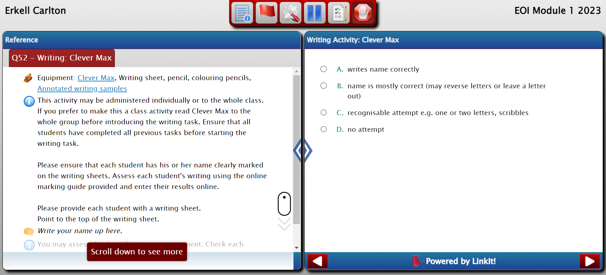

### Progressing through assessment

For validity purposes, it is recommended that tasks be completed in the order outlined in each module. It is also recommended that each individual assessment is conducted in one sitting to ensure the most accurate and reliable results.

All tasks need to be completed and the module **submitted** to produce reports and generate data, including scale scores and indicative Victorian Curriculum F-10 levels.

### Saving and pausing assessment

In some circumstances it may be necessary to use the *Pause Assessment* button and continue the interview later. An assessment can be saved at any time by clicking *Pause Assessment* button which will then prompt you to pause and save to finish later.

### Completing the assessment where a student is having difficulty

The tasks are very different in nature and students may be able to respond to some but not others. Each student should have an opportunity to attempt every task.

Where a student cannot continue with a particular task, the ‘no attempt’ option in the multiple-choice answers can be selected, or the assessment can be stopped without completing all of the tasks. A prompt will ask if you want to complete the assessment even though there are unanswered questions. Care should be taken when interpreting reports in such instances, as non-completion of items may not be indicative of a student’s capabilities.

In some circumstances it may be necessary to end a task before all questions in the task have been attempted by the student. This may occur if the student is clearly unable to provide further answers to the questions in the task. For example, some EAL learners in the early stage of their EAL learning may have insufficient English to understand or respond to some tasks. It is important that a task is ended rather than making an individual feel uncomfortable during the interview.

# Recording student responses

Each question or task in the EOI has a rubric of multiple answers that is used to record student responses. Psychometric analysis of the EOI has established the relative difficulty of each question in comparison to all the other questions, and a score assigned to indicate the difficulty of each question. Easy items have the lowest scale scores and as items become more difficult their scale score increases.

When a student’s response is entered into the EOI, 3 processes occur:

* the raw scores for the individual questions are aggregated
* the total raw score is converted to an EOI scale score
* the EOI scale score is converted to an indicative Victorian Curriculum F-10 level.

Scale scores reflect student performance and are indicative of the quality of a student’s responses against items of varying degrees of difficulty. EOI reports using scale scores are found in the results table under the Class Profile, and the Student Profile. The scale score is also used for the tracking growth report. All other EOI reports use raw scores.

## Using the scoring rubrics to evaluate student responses

Every question in the EOI has a scoring rubric. These rubrics can inform teacher practice by guiding teachers’ evaluations of the responses students give to each question in the EOI.

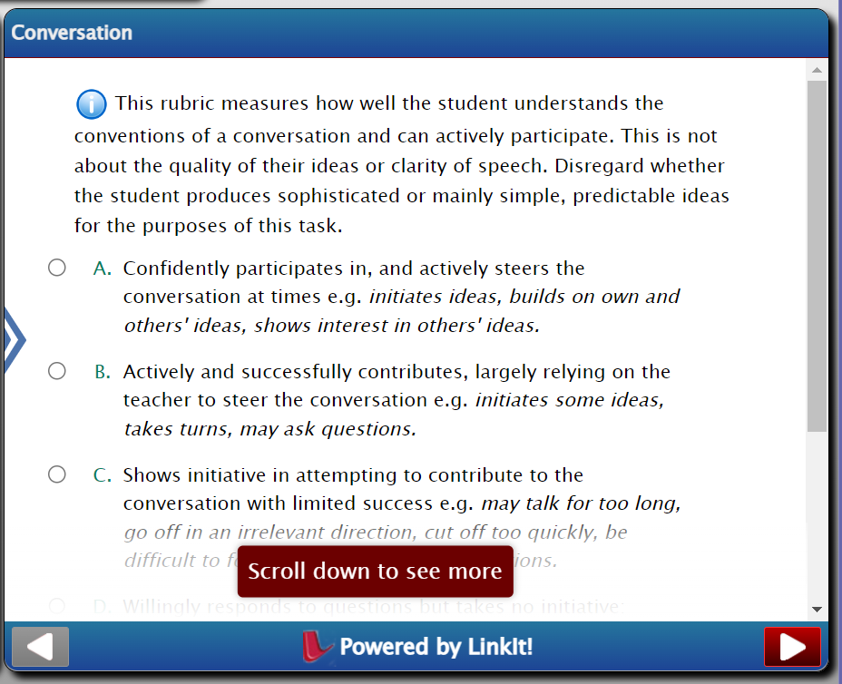

Each answer option describes in detail the varying responses students may give to different questions.

Option A of the rubric corresponds to the highest-level response. This includes:

* the correct answer (where the answer is simply right or wrong)
* in more complex questions, the most ‘sophisticated response’
  + such as the most structured, organised, and coherent writing response
  + the most engaged and purposeful oral interaction.

Students consistently providing this highest-level response are demonstrating mastery of the skills being assessed in the associated task.

Subsequent response options describe responses reflecting different degrees of student proficiency. The wording of these categories can inform the teacher of the level of achievement of the student as they work towards mastery of the skill being addressed. This information will help teachers to identify the focus of teaching and support required for individual students. The amount of time and support will vary depending on the pattern of student responses.

## Phonics rubrics

The real English words and non-words used across the 4 modules represent several different graphemes and phonemes. The rubric consists of 3 options:

* Correct
* Incorrect
* No attempt.

When decoding a non-word, all plausible alternative pronunciations are acceptable, as outlined in the individual administration guides in the Insight Assessment Platform learning library.

If the student response is marked as incorrect, the student’s actual response or attempt must be entered into the text box in 50 characters or less. Recording the attempt provides qualitative data to understand each student’s learning needs and focused teaching opportunities. Examples of how to record an incorrect response are provided in this part of the EOI assessment. This page of the EOI provides some examples of how to record the error analysis.

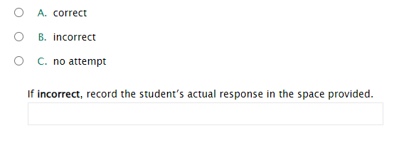

For more information on recording, analysing and next steps for the phonics task, handbooks have been developed for each EOI Module and are located in Insight Assessment Platform learning library

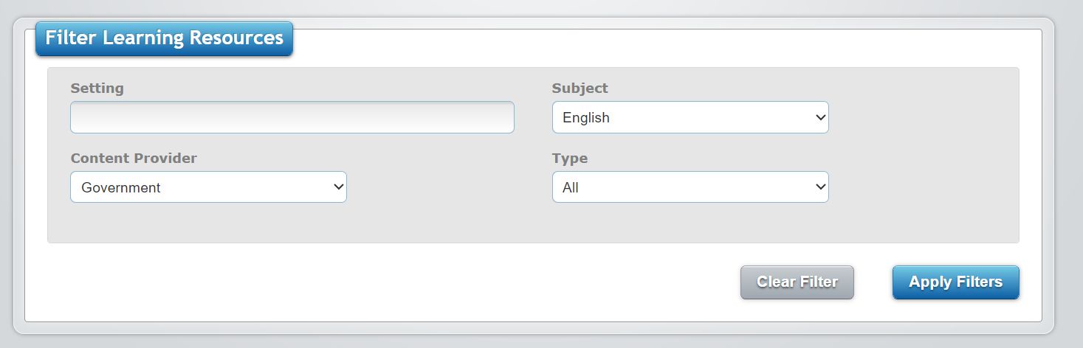

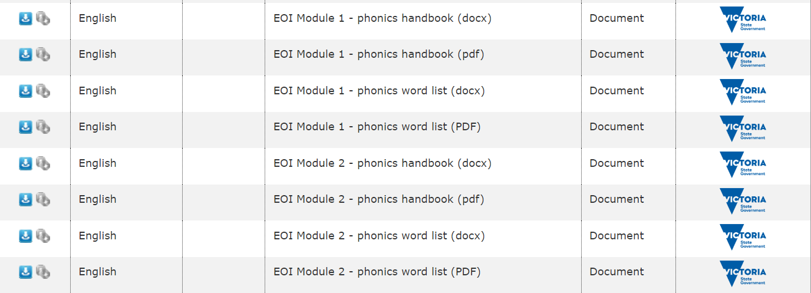

A screenshot of the Insight Assessment Learning Library


## Writing rubrics

The writing rubrics indicate what the teacher needs to look for to evaluate the writing. The rubric categories describe the range of responses that are typically demonstrated in writing.

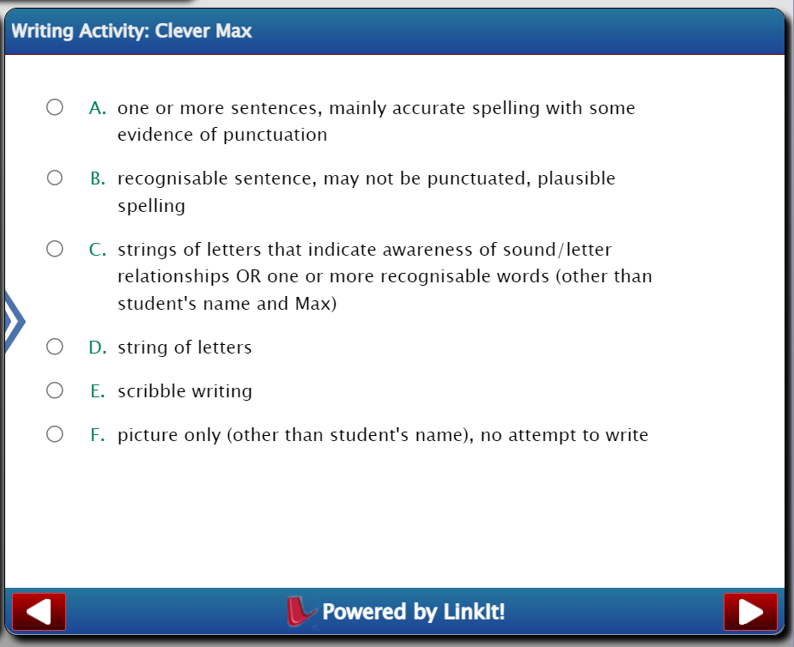

The student is asked to read their own writing and the teacher evaluates how well the student’s reading matches their writing. The teacher also evaluates the relevance and coherence of the content, the sentence construction, and the spelling. A collection of [annotated writing samples](https://fuse.education.vic.gov.au/?J8RQ7Z) is available to support teachers’ judgements about the categories of the scoring rubrics for the writing.

The scoring rubrics differentiate correct spelling and stages in approximating the correct spelling for difficult words. The writing rubrics indicate what the teacher needs to look for to evaluate the writing and describe the range of responses that are typically demonstrated in writing. The teacher evaluates the relevance and coherence of the content, the range of sentence constructions, the spelling, and the punctuation.

# Student Profile

## How to Access

1. Reporting 

2. Reporting Dashboard 

3. View Class 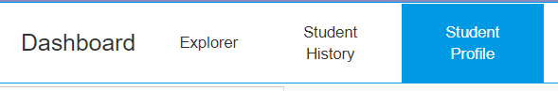

## About the Student Profile

The Student Profile is a single access point for all literacy data collected on the Insight Assessment Platform. The Student Profile pulls together multiple sets of data and simplifies navigation to useful graph to provide a holistic view of each student’s capabilities in literacy. The ability to collate data sets to support teachers in differentiation, scaffolding learning, and identifying literacy learning difficulties.

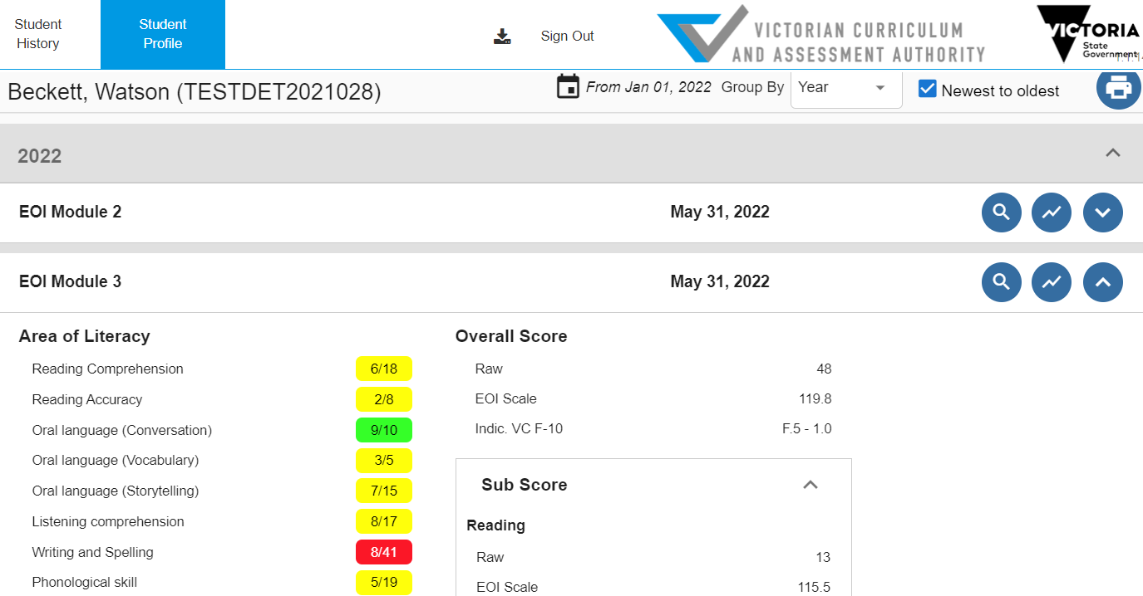

## Features of the Student Profile

The Student Profile includes data from the

* EOI
* Diagnostic Assessment Tools in English (DATE),
* Transition Learning and Development Statement (TLDS)
* Abilities Based Learning and Education Support (ABLES).

By default, the data is grouped by year, in chronological order, with most recent at the top of the screen. Customisation options are available along the top right banner of the Student Profile and includes:

* extending the date range
* grouping by subject
* displaying oldest data at the top of the screen.



The Student Profile links directly to the:

* TLDS that is attached to a student.
* The ABLES report for each student.

## EOI Data

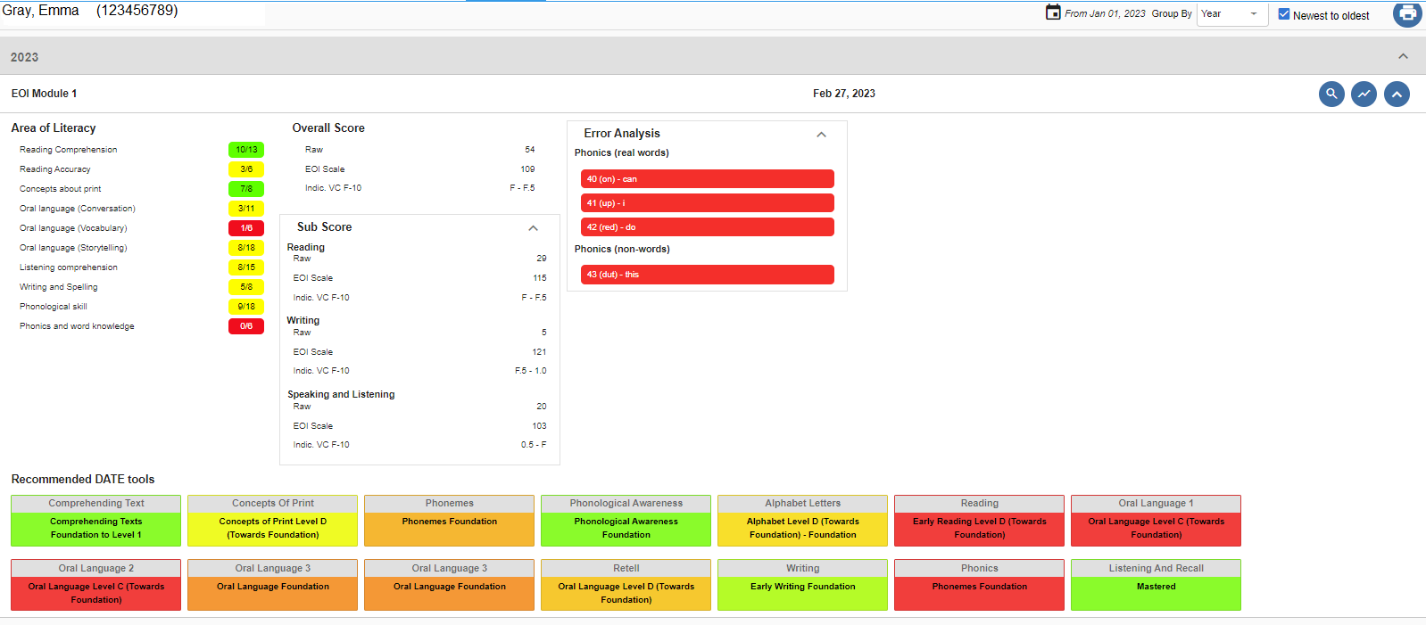

The EOI results display:

* a direct button to an Item Analysis report and EOI module comparison report (circled in black)
* overall EOI scale score, raw score and correlating indicative Victorian Curriculum level (circled in blue)
* scoring correlating indicative Victorian Curriculum level for the Dimensions – reading, writing, speaking and listening (circled in yellow)
* the EOI to DATE report indicating suitable DATE tools to substantiate EOI data (circled in green)
* the Areas of Literacy tags and the related raw score as a fraction for each area (circled in purple)
  + The Area of Literacy raw scores include traffic light indicators, highlighting the scores in green (75% and above), yellow (25-74%), and red (24% or below).
* the student’s incorrect attempts at the phonics word items, if entered into Insight by the teacher (circled in red).

## Areas of Literacy

Each item of the EOI modules is tagged within 1 of 10 areas of literacy:

* Reading Comprehension
* Reading Accuracy
* Oral language (Conversation)
* Oral language (Vocabulary)
* Oral language (Storytelling)
* Listening comprehension
* Writing and spelling
* Phonological skill
* Phonics and word knowledge.

The areas of literacy tags are used in many of the EOI reports and the Student Profile to assist educators in collating and analysing literacy data and the early indication of literacy learning difficulties.

# Reports

A range of reports for the EOI can be generated from the Insight Assessment Platform. Reports can only be generated for students whose assessment/s have been ***completed in full and submitted****.*

All modes of English (Speaking and Listening, Reading and Viewing and Writing) in the assessment must be completed before an EOI scale score can be calculated for a student.

There are several reports that can be generated and customised to view student data. Reports can be generated for an individual student, a pre-defined group, or a whole class. School Assessment Administrators can generate reports for any class as well for the whole school.

Once the class of students has completed the EOI, information at an item level across the class can be easily compared. Groups of students with similar teaching needs can be identified based on their responses. If students within a year level are administered different modules the overall results will be directly comparable, however other comparisons can only be made by matching similar items across the different modules.

## Indicative Victorian Achievement Level

When an assessment is finalised students receive an EOI scale score. Some reports use the EOI scale score for the overall score, or for 1 of the 3 Dimensions. This EOI scale score is then translated into the equivalent indicative Victorian Curriculum achievement level. This score will enable teachers to track student progression from previous years. The “F” refers to Foundation level in the Victorian Curriculum.

A summary of recommended reports available through the Insight Assessment Platform follows in the next section.

# Summary of Reports

The following reports are recommended for use with the EOI.

## EOI Summary

**What it shows:**

Number of student assessments and level distribution across indicative Victorian Curriculum F–10 levels.

**How to access:**

1. Reporting 

2. Reporting Dashboard 

3. View Class 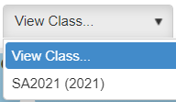

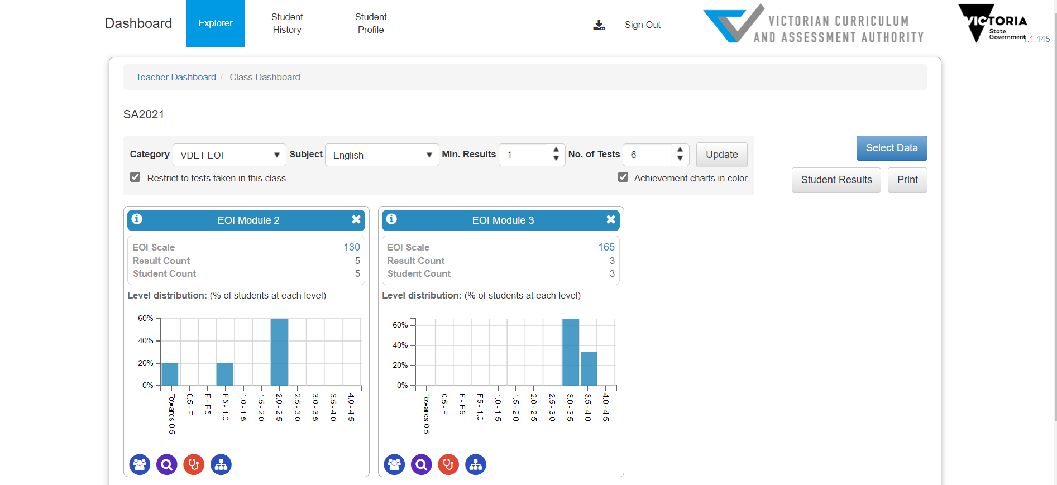

## Class Profile

**What it shows:**

EOI scale score and indicative Victorian Curriculum F–10 level. Can be ordered by EOI Scale score and student name by clicking the column headings. Further columns can be added to provide more data such as scoring by modes.

**How to access:**

1. Reporting 

2. Reporting Dashboard 

3. View Class 

4. Class Profile icon 

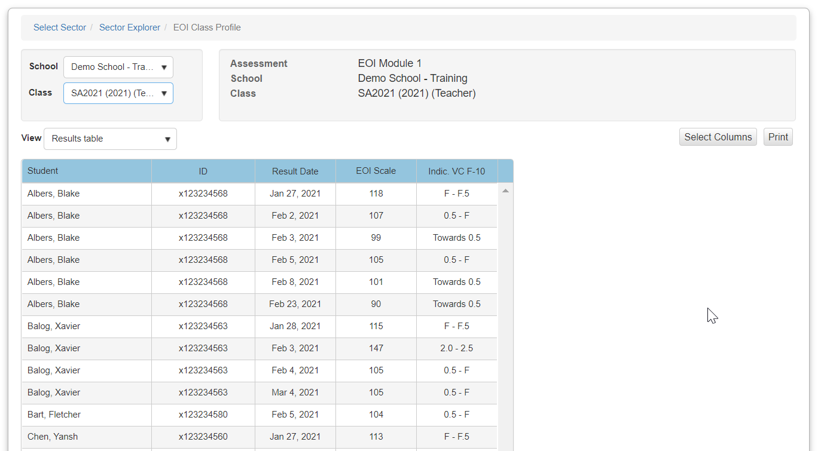

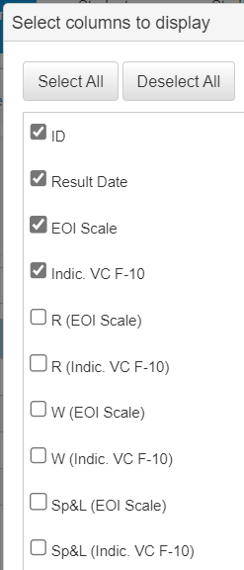

## EOI to DATE Report - Class

**What it shows:**

Appropriate level of [Diagnostic Assessment Tools in English (DATE)](https://www.education.vic.gov.au/school/teachers/teachingresources/discipline/english/Pages/date.aspx) for further testing based on EOI Scale score. Use Select columns to show additional information (EOI Scale Score, Victorian Curriculum F–10 Level). DATE tools can be assigned via Online Testing > Assign Online Tests.

**How to access:**

1. Reporting 

2. Reporting Dashboard 

3. View Class 

4. Class Profile icon 

5. Drop-down box > DATE tools 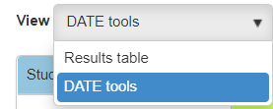

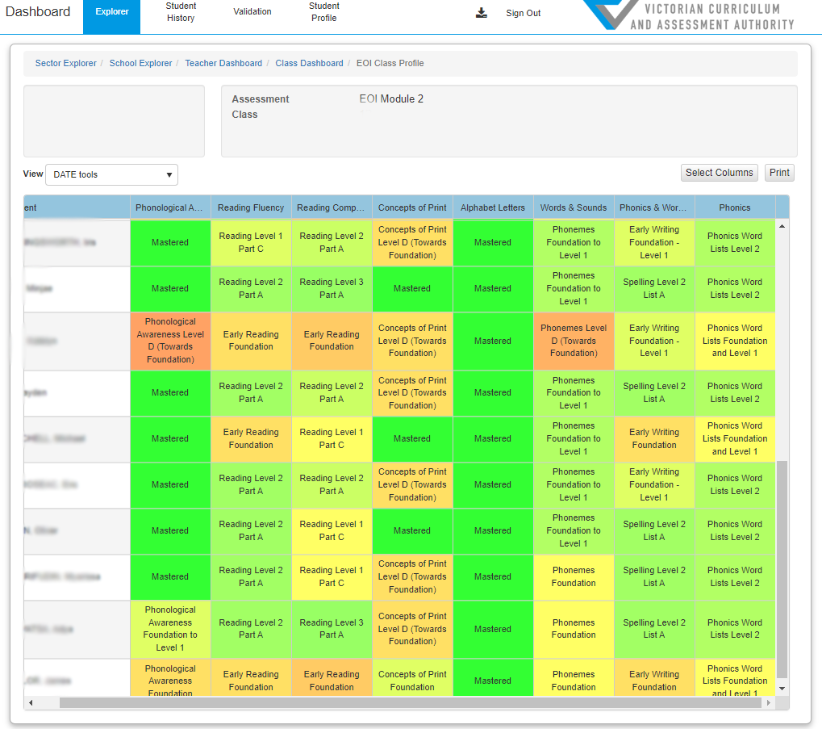

## EOI to DATE Report – Students

**What it shows:**

Individual student results showing the Appropriate level of [Diagnostic Assessment Tools in English (DATE)](https://www.education.vic.gov.au/school/teachers/teachingresources/discipline/english/Pages/date.aspx) for further testing based on EOI Scale score. Use Select columns to show additional information (EOI Scale Score, Victorian Curriculum F–10 Level). DATE tools can be assigned via Online Testing > Assign Online Tests.

**How to access:**

1. Reporting 

2. Reporting Dashboard 

3. Student Profile 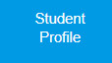

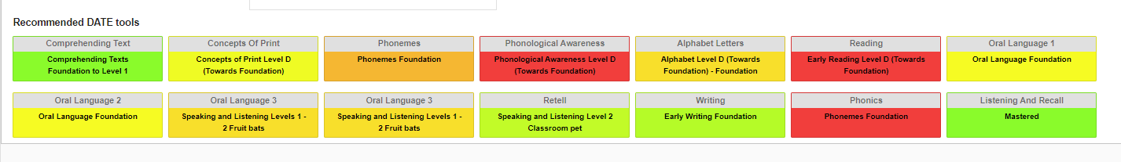

## Item Analysis Report

**What it shows:**

Item Analysis shows students’ responses compared with class. Check the ***Custom Tags*** checkbox to select the grouping of items by mode, area of literacy, or task, with the display showing below the question table.

**How to access:**

1. Reporting 

2. Reporting Dashboard 

3. View Class 

4. Item Analysis icon 

5. Student Reports 

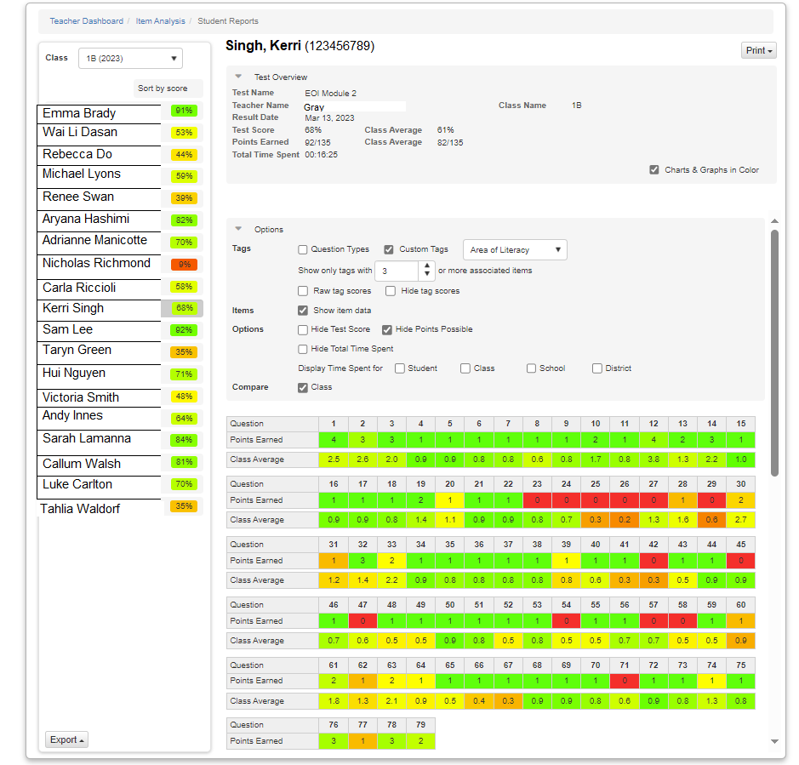

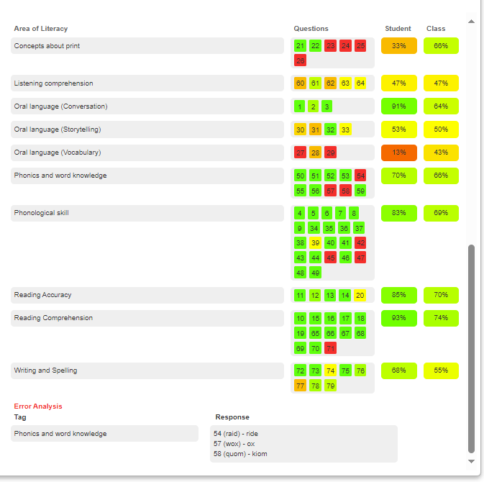

## EOI Module Comparison Report

**What it shows:**

Individual student results showing comparison across the completed Modules of EOI.

**How to access:**

1. Reporting 

2. Reporting Dashboard 

3. Student Profile 

4. Select date range 

5. Student Report 

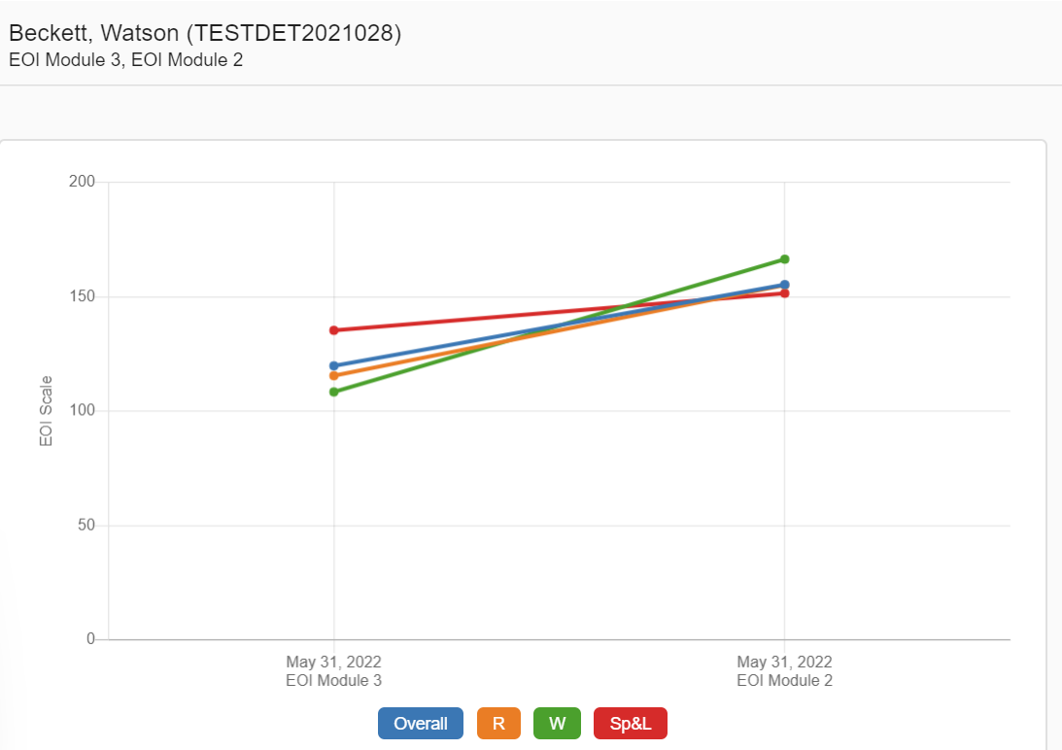

## Class Diagnostic

**What it shows:**

Breakdown of student performance by mode, area of literacy, task, or question. Clicking on an individual tag (e.g., LS: Listening and Speaking) to access the side score table showing the range of student performance.

**How to access:**

1. Reporting 

2. Reporting Dashboard 

3. View Class 

4. Class Diagnostic 

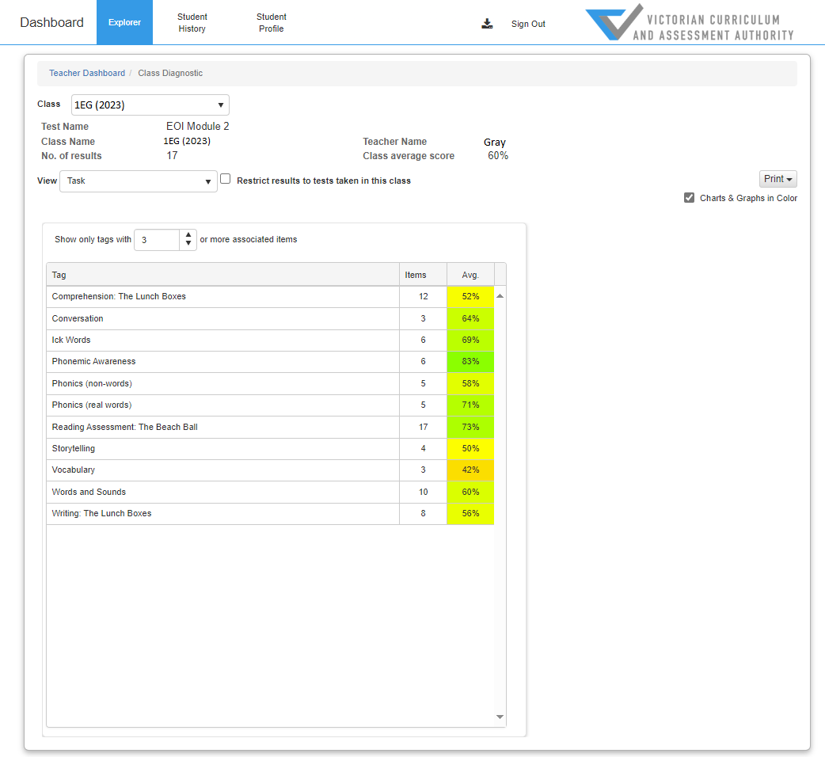

## Grouping Report by EOI mode or task

**What it shows:**

This report automatically groups students with similar needs. Students can be grouped by area of literacy, mode, or task. There are a number of filter options to customise groupings. The columns represent each of the tags selected, for example (1), represents reading, (2) represents writing, (3) represents speaking and listening.

**How to access:**

1. Reporting 

2. Reporting Dashboard 

3. View Class 

4. Grouping 

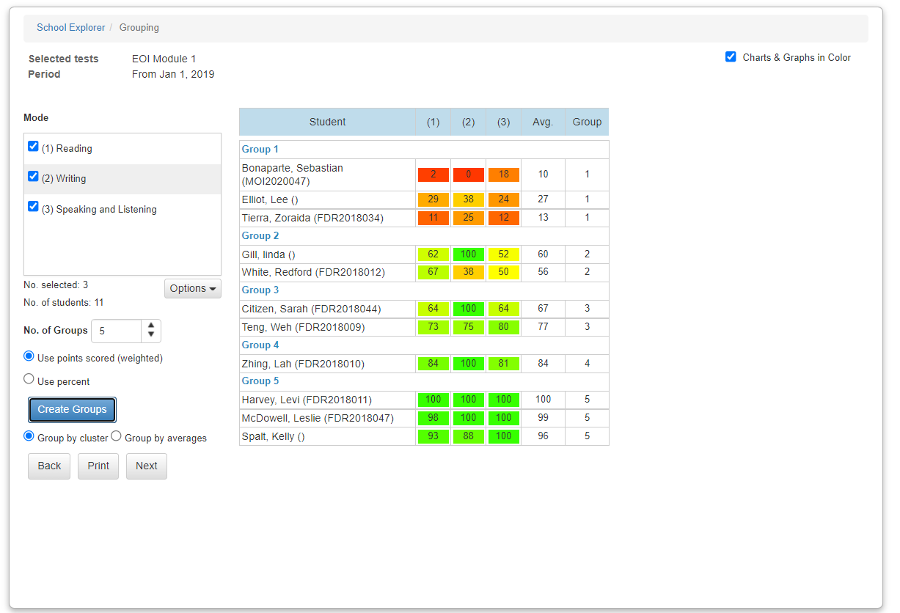

## Custom Reports

**What it shows:**

These reports provide a range of filters to view data in a number of ways, using groupings, tags, and representing data in graphs and tables.

**How to access:**

1. Reporting 

2. Reporting Dashboard 

3. View Class 

4. Select Data 

5. Select tests 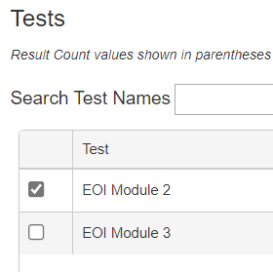

6. Other Reports > Custom Reports 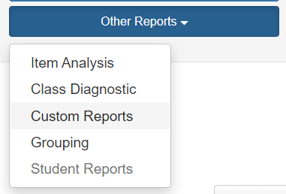

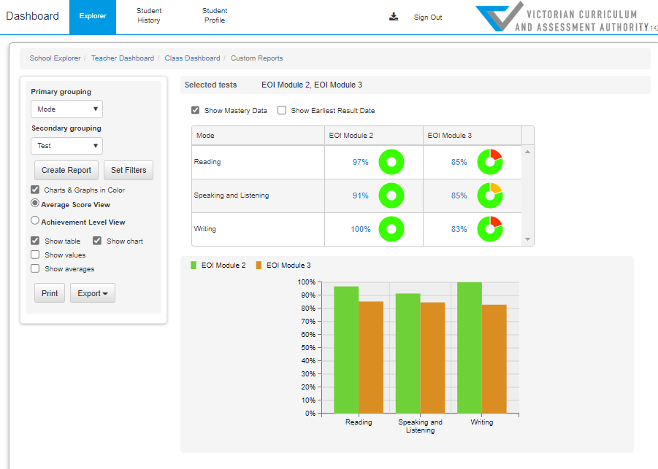

## Student History

**What it shows:**

Individual student history for all Learning Areas.

**How to access:**

1. Reporting 

2. Reporting Dashboard 

3. Student History 

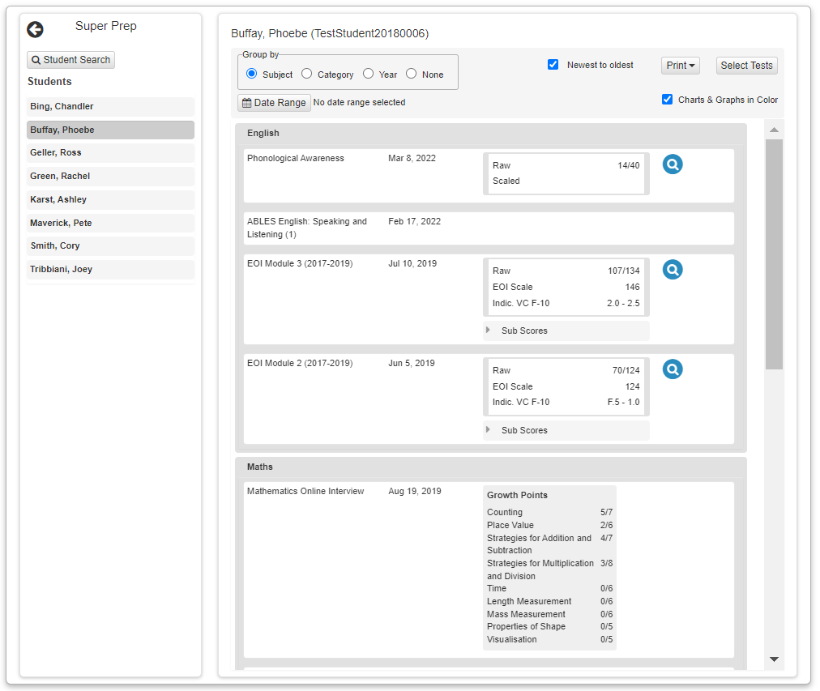

## Assignment Reviews – Individual students

**What it shows:**

Individual student responses to questions, with the ability to add anecdotal notes for each question, and to view the original question instructions through the reference link.

**How to access:**

1. Online Testing 

2. Manage Test Codes 

3. Scroll Down > Review Test Assignments 

4. Review icon 



5. Select Student to Review 

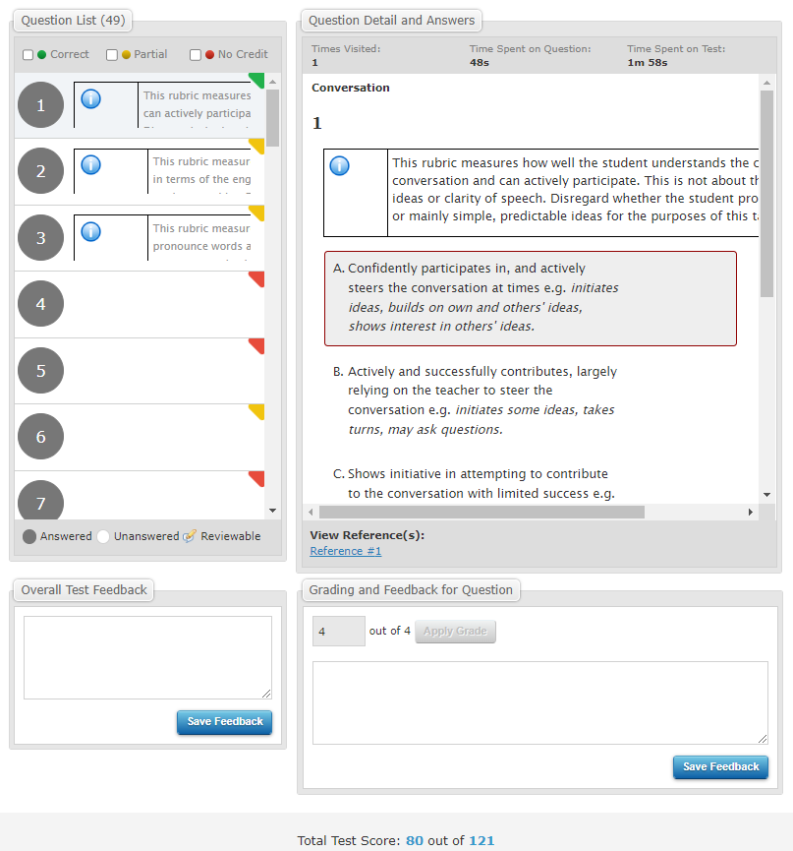

# Help and Support

## EOI Technical Support

### What to do in the first instance when experiencing technical difficulties

Teachers can:

* speak with their School Assessment Administrator if they have any technical difficulties with administering the EOI
* refer to the Support documentation on the Insight Assessment Platform:

<https://www.vcaa.vic.edu.au/assessment/f-10assessment/insight/Pages/index.aspx?Redirect=1>.

If the issues cannot be resolved in-house, the School Assessment Administrator or teachers can contact the department’s IT service desk and report the issue(s).

### Contacting the department’s IT Service Desk

**Technical assistance is available for schools via the** [**services portal**](https://services.educationapps.vic.gov.au/dp)**.**

**When lodging a services request, provide as much information about the issue as possible including name, school and campus number. Screenshots displaying error messages should also be provided where possible.**

**Email:** [**servicedesk@education.vic.gov.au**](mailto:servicedesk@education.vic.gov.au)

**Phone: 1800 641 943**

## Further Support

### Contacting the Literacy Unit in the department’s central office

For general, non-technical enquiries, including in relation to EOI kits and EOI use to support literacy teaching and learning, email [studentlearning@education.vic.gov.au](mailto:studentlearning@education.vic.gov.au)

### VCAA FAQ’s

Visit the [[Victorian Curriculum and Assessment Authority’s FAQs](https://www.vcaa.vic.edu.au/assessment/f-10assessment/insight/Pages/faq.aspx)](https://www.vcaa.vic.edu.au/assessment/f-10assessment/insight/Pages/faq.aspx) for information on administering and using the Insight Assessment Platform.